Capstone 3 Project Report
Prince Zogli, PhD.
10/11/21

Title: Identifying the best predictive feature for risk of heart disease.

Mentor

Eleanor Thomas

Introduction:
Heart disease could result from many disorders of the heart and blood vessels such as cerebrovascular disease, coronary heart disease(CHD), hypertension, and heart failure.
Coronary heart disease(CHD) is the leading cause of death worldwide and a major public health concern. In the USA, CHD is one of the leading causes of death. One person dies every 36 seconds from CHD, culminating in 659,000 deaths annually. The costs the USA 363 billion each year from 2016 to 2017^{1,2}. This occurs mostly due to buildup of plaque in arteries(small blood vessels). Certain behavioral activities increase the risk of developing CHD including smoking, low physical activity, unhealthy diets, and stress. Other ailments like diabetes, obesity, and high blood pressure and cholesterol can also increase CHD risk.

Problem statement
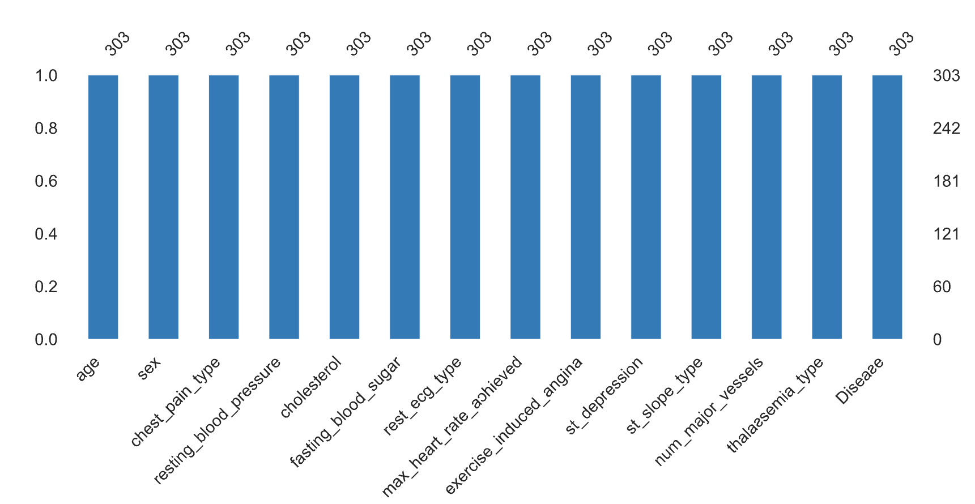
Figure 1: Features of heart disease data to be modeled for identification of strong predictors of CHD

Though most heart diseases are highly preventable with simple lifestyle modifications, it is difficult to identify high risk patients because of the multifactorial nature of contributory risk factors outlined above. Due to such constraints, it's ideal to rely on Data Mining and Machine Learning(ML) approaches for predicting risk for CHD disease.

Objective
In this project I will use ML models to predict whether a patient has a risk for developing CHD
The question to be answered include the following:
- What factors constitute strong predictors of risk to suffer heart attack? Which sex is most prone to heart disease and why so?
From a real estate business perspective knowledge of housing price determinants.
This will help doctors narrow down on list of risk factors and accurately help patients at risk of heart attack.

Data, Justification, and source:
The Cleveland dataset is being used for this study given its availability. Thr data is publicly available here: https://www.statista.com/statistics/184391/heart-disease-risk-in-the-us-by-age/.
This database contains 76 attributes, but only a subset of 13 will be used to model risk for heart disease.
The 13 features and the target (Disease) are described below:
- age: The person's age in years
- sex: The person's sex (1 = male, 0 = female)
- cp: The chest pain experienced (Value 1: typical angina, Value 2: atypical angina, Value 3: non-anginal pain, Value 4: asymptomatic)
- trestbps: The person's resting blood pressure (mm Hg on admission to the hospital)
- chol: The person's cholesterol measurement in mg/dl
- fbs: The person's fasting blood sugar (> 120 mg/dl, 1 = true; 0 = false)
- restecg: Resting electrocardiographic measurement (0 = normal, 1 = having ST-T wave abnormality, 2 = showing probable or definite left ventricular hypertrophy by Estes' criteria)
- thalach: The person's maximum heart rate achieved
- exang: Exercise induced angina (1 = yes; 0 = no)
- oldpeak: ST depression induced by exercise relative to rest
- slope: the slope of the peak exercise ST segment (Value 1: upsloping, Value 2: flat, Value 3: downsloping)
- ca: The number of major vessels (0-3)
- thal: A blood disorder called thalassemia (3 = normal; 6 = fixed defect; 7 = reversable defect)
- target: heart disease (0 = no, 1 = yes)

Data Wrangling, cleaning, and Exploratory data analysis:
Data is clean with no missing values. There are 3 data types: Continuous (C): which is quantitative data that can be measured, Ordinal Data(O): Categorical data that has a order to it (0,1,2,3,) and Binary Data(Bi): data whose unit can take on only two possible states ( 0 &1 ).

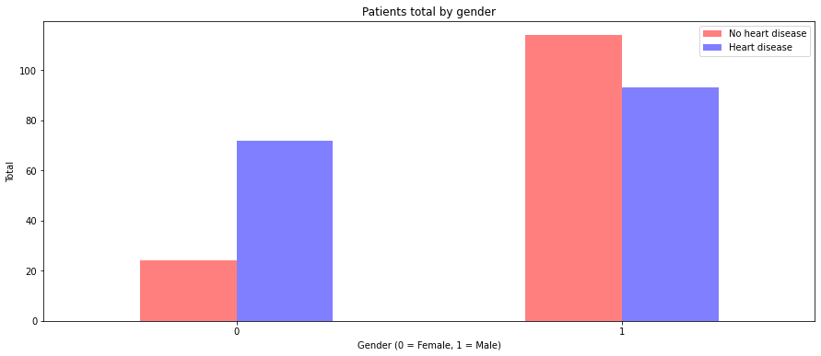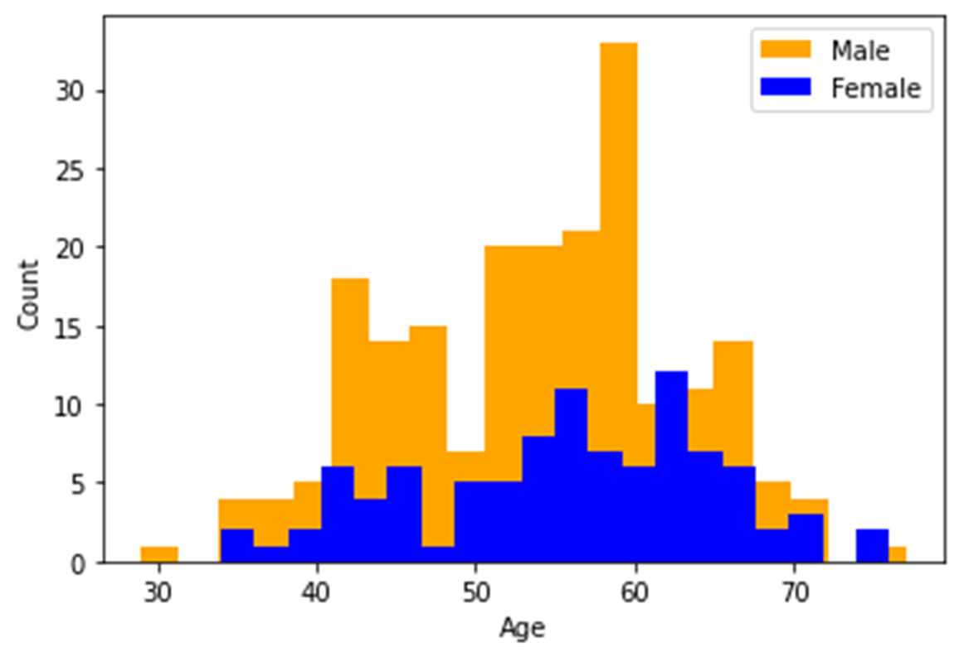
Figure 2: heart disease distribution by sex and age

There are more men with heart disease as there are women. However, there were twice men compared to women in the data, hence it may be misleading to assume men are more prone to the disease than women(Figure 2).
To get a better view of the relationships, a correlation plot was generated. We found 30-43% correlation between risk of disease and Chest pain, heart rate, st_depression, agina and thalassemia(Figure 3).
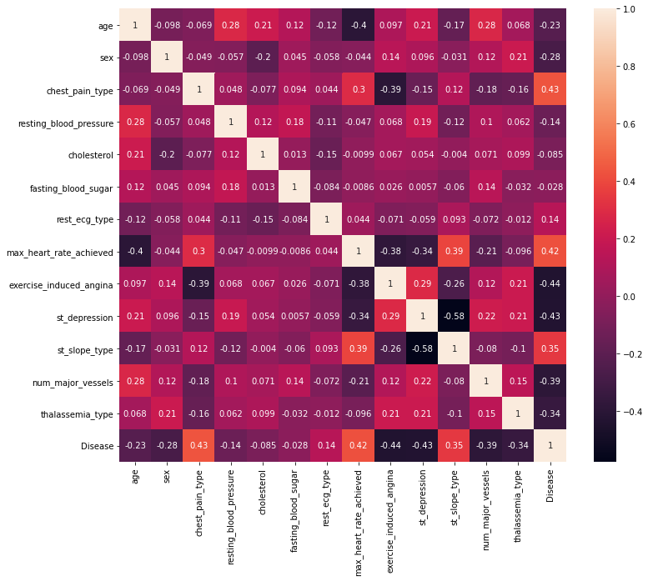
Figure 3: Correlation among features

It is also evident from the correlation plot that predictive features such as Age & blood pressure, Chest pain & heart rate among others have some degree of correlation. It will be imperative to perform feature selection to build models.
Thus, to ensure certain features do not overly skew our model, the data was normalized.

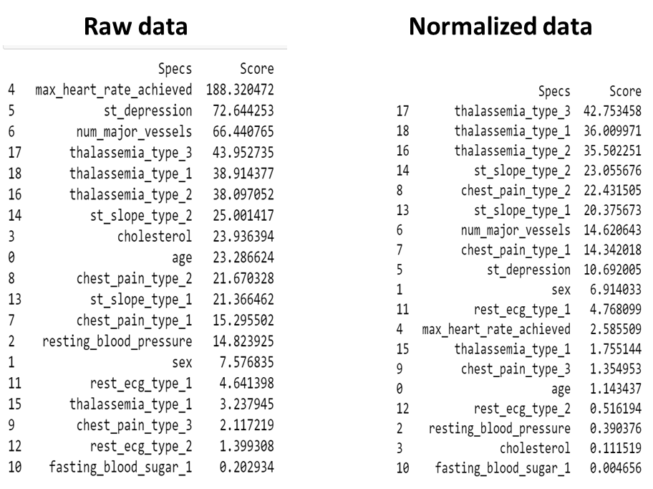
Figure 4: Data normalization and feature selection

As revealed While heart rate seemed the most important feature in the raw data, scaled data suggests thalassemia is a more important feature to consider.

Building models
The data was split into train and test using 75:25% ratio. Train data was used to train 3 models, Linear regression, Support Vector Machine(SVM), and k-nearest neighbors (KNN) and Random Forest.
Model accuracy was used to select Logistic regression as the best model. This also had a smaller RME of 0.125

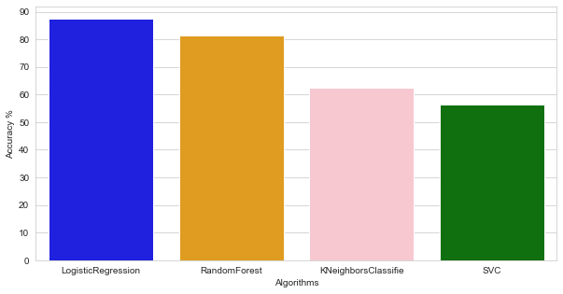
Figure 5: Comparing model performance

Conclusion:
- Logistics Regression was the best performing model.
- Features including thalassemia, heart rate and St-Slope a top predictors of heart disease
Future direction:
- Remove features with less influence on our model and re-train the models.
- Generate more data to use.

References:
1. Centers for Disease Control and Prevention. Underlying Cause of Death, 1999–2018. CDC WONDER Online Database. Atlanta, GA: Centers for Disease Control and Prevention; 2018. Accessed March 12, 2020.

2. Virani SS, Alonso A, Aparicio HJ, Benjamin EJ, Bittencourt MS, Callaway CW, et al. heart disease and stroke statistics—2021 update: a report from the American Heart Associationexternal icon. Circulation. 2021;143:e254–e743.

